This week (June 1-5) I would like you to:
- Familiarize yourself with the website “Breezin’ Thru Theory- Next Gen”
- Review lesson 1-1 and 1-2
- Scroll down on the website to find and play the game “Stickin’ The Staff”.
- Try some of the “Mad Dash Drills” to increase your speed.
HERE’S HOW!!!!
1.Go to website:
Breezinthru.com/login

Username: btfun_7765
Password: jazz464
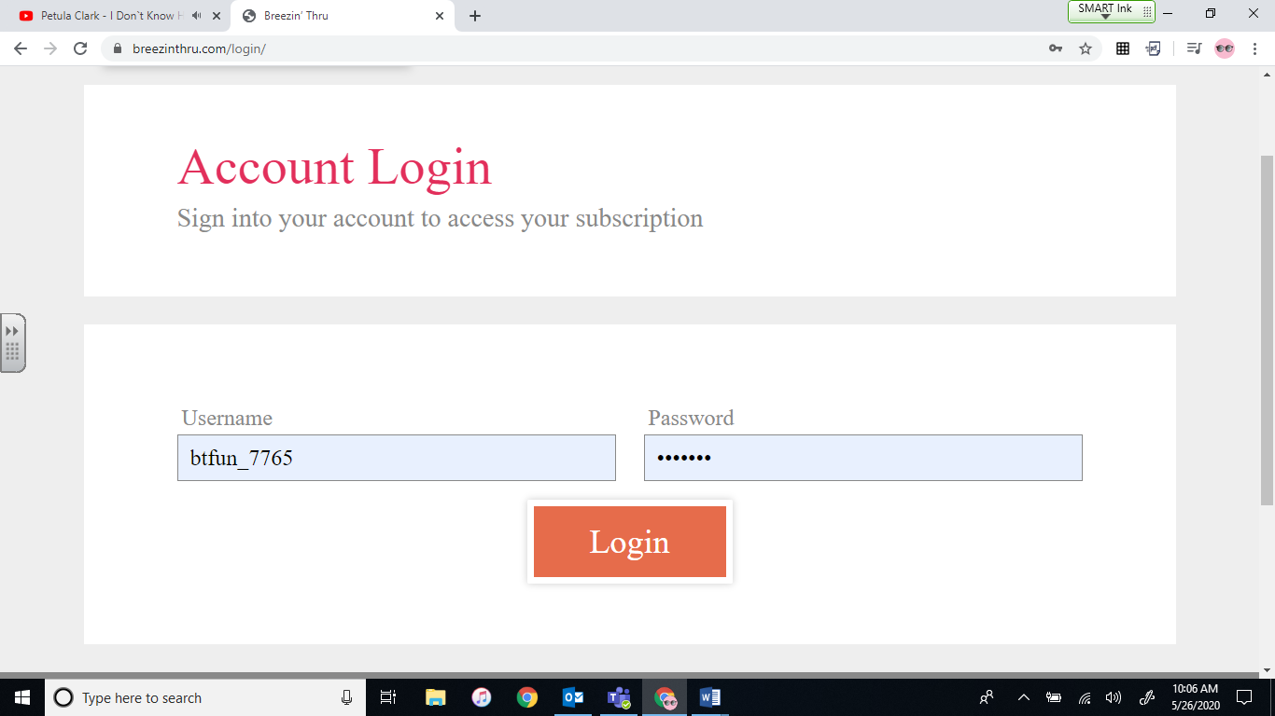
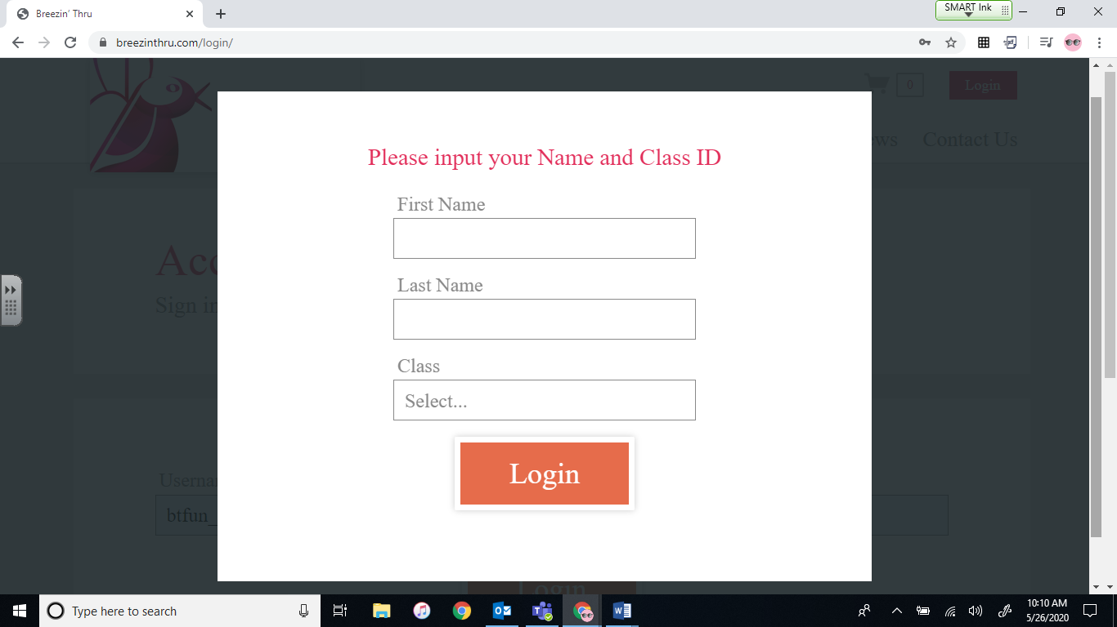
2. Log in so I can see your progress. No one else will see this.
-Type in your name
-Choose your grade from the “Class” drop down menu
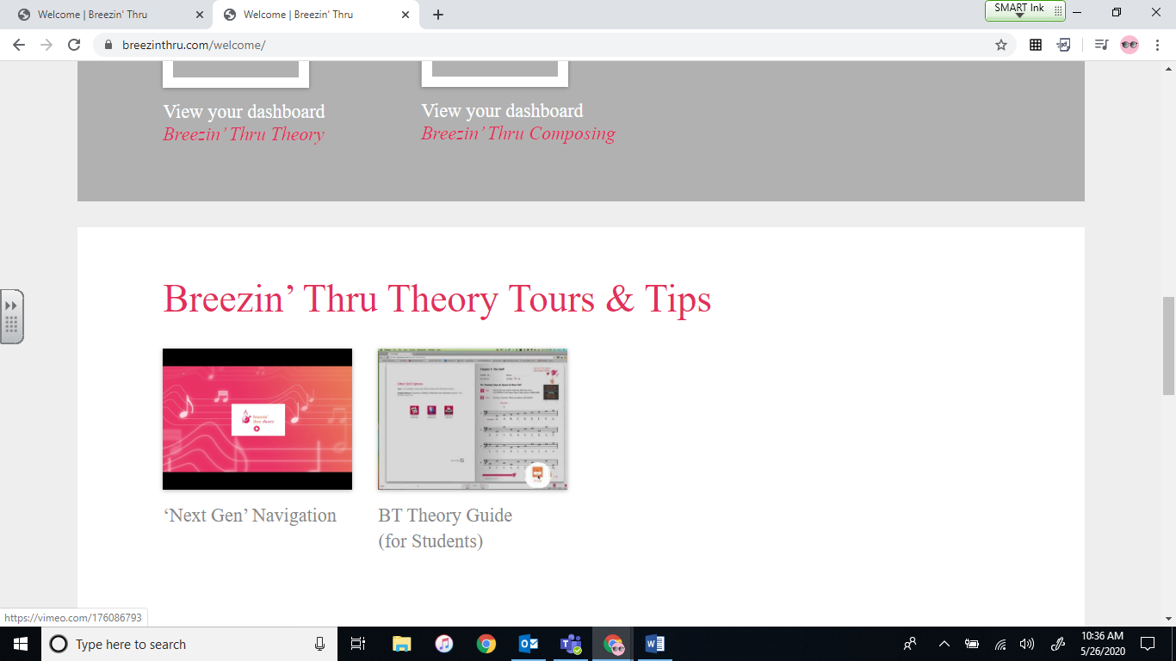
3. Enter Breezin’ Thru Theory Next Gen
First, scroll down on this page to find some “Tours and Tips” watch the first video to help you learn how to navigate the website.
Next, scroll back up and click on Breezin’ Thru Theory to start the lessons
